A Medical Student’s Summer in Research Nicola Attoe

As a graduate entry medical Student at Southampton University, we are lucky to get an extremely long summer break of about 10 weeks in the first and second years. For some this comes as a welcome break and is often spent travelling, visiting home and having a holiday. For others, like myself it can soon become boring and is used as a much-needed opportunity to earn some money!

I spent my first summer here working as a healthcare assistant at the General hospital on the Acute Medical Unit and A&E. This is very hard work, with long hours and nights but is a great way to prepare you for the daily (and nightly) toil of a being a foundation doctor. It also gives a great insight into general working life in a busy hospital.

This year, however, I was hoping to take part in some research and had set about emailing various supervisors offering myself as a volunteer lab assistant. Coincidentally, shortly after doing so I received an email from Roxanna Carare explaining that she had applied for a bursary to fund a medical student on a 10-week summer research project. HOW PERFECT. I quickly responded and was delighted to hear that I’d been accepted.

I was to be working on a project aimed at finding novel biomarkers for the diagnosis of Alzheimer’s disease. This involved performing immunohistochemistry on thinly sliced slides of brain tissue in order to stain and visualise different components of the basement membrane. The images of my slides were to be sent to the Computational Imaging department and from there they would be analysed for specific branching patterns of cerebral arteries, which are associated with Alzheimer’s. These results will hopefully be useful in developing a new method of early diagnosis when applied to cerebral angiography.

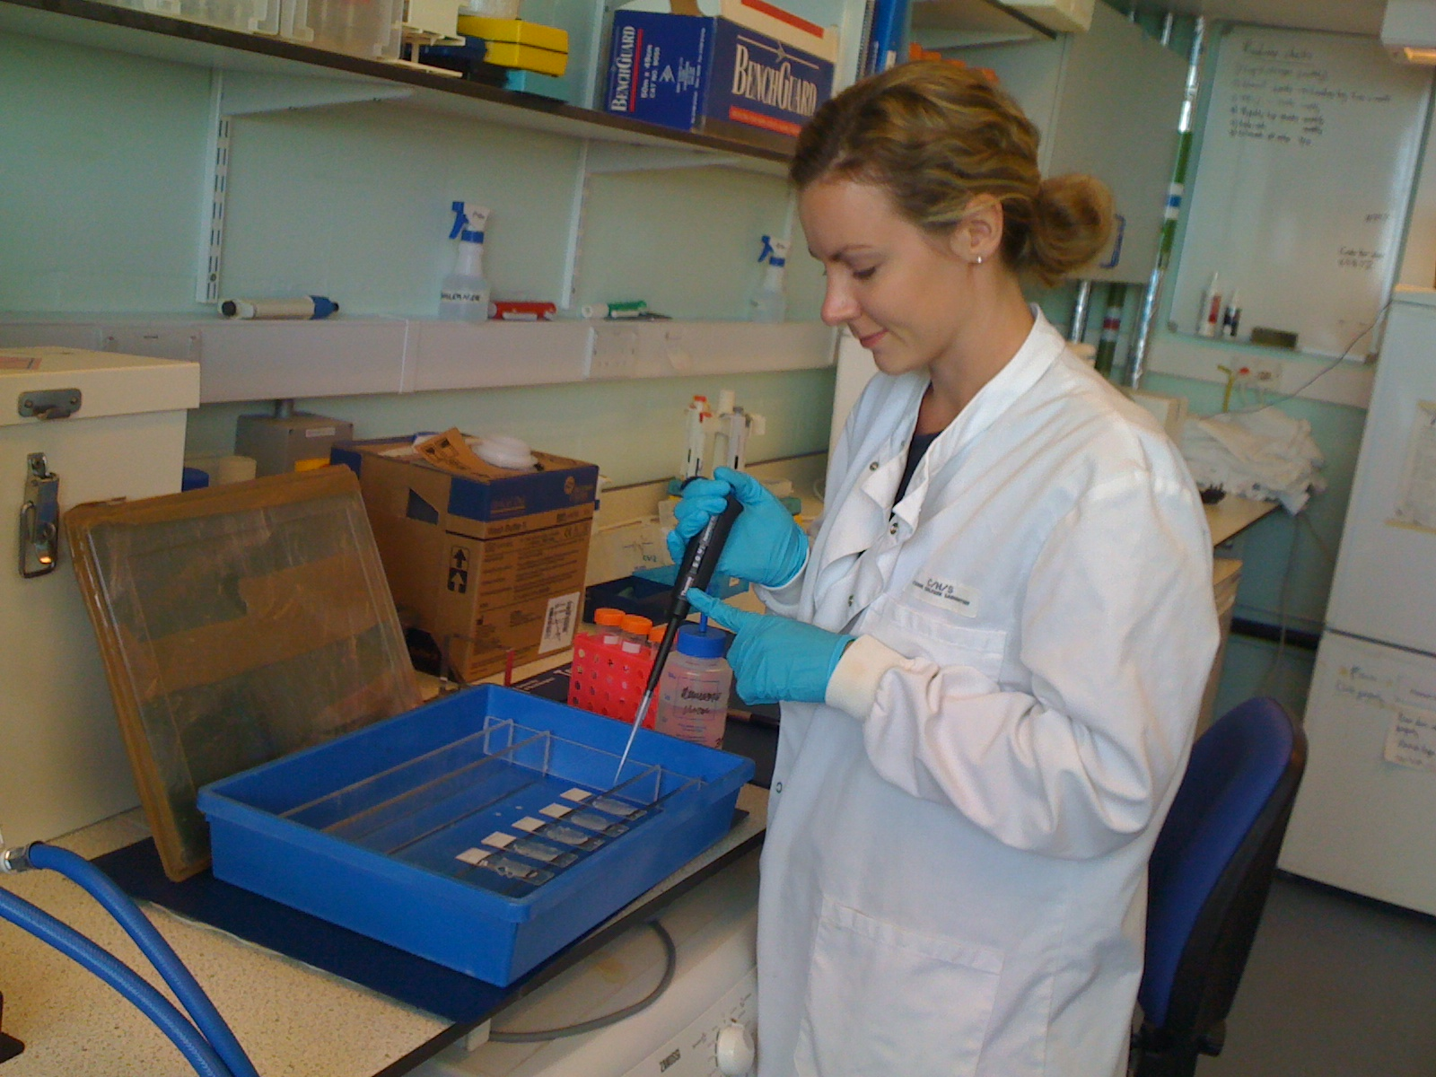
I was entrusted a lovely set of slides from a rare brain bank in Edinburgh. The slides were from young brains (20-25 years) of patients who had died without any trauma to the brain, which as you can imagine is not a common occurrence.

My first few protocols went well and I had produced some nice images (see collagen stained large artery below). However, I was soon to realise the unpredictability of scientific research when, despite thinking I’d done everything right, my slides were not staining properly! I was left feeling deflated as I’d not only wasted 2 days preparing the slides but the slides were now wasted. Thankfully everyone was really kind and assured me that this happens to everyone and sometimes you never find out what went wrong. So it was back to work the next day to try again.

I was also asked to present some findings to the group who awarded my bursary the Engineering and Physical Sciences Research Council (EPSRC). This was a nerve-wracking but valuable experience and a great chance to practice my presenting skills (thankfully Roxana was there to answer some of the more difficult questions they asked!).

By the end of the 10 weeks I had stained all of my slides for 4 different proteins, ruined a handful of slides, earned some money, hopefully produced some data that can be used in a paper and even managed to get a week off to go to the Olympics. I would recommend this type of summer scheme to all medical students as it is important to understand the meticulous, lengthy and sometimes frustrating work that goes into all of the new diagnostic tests and treatments that we will one day be taking for granted on the wards.

I would like to thank Roxana Carare and Maureen Gatherer for all their help and support and for making my summer a highly worthwhile and enjoyable experience and the EPSRC for awarding the bursary.

